Music Manifest Validation Testing

Test Case 1 – Customer Actions
Initial state – No lists created. The expected outcome after the below tests is a created list with 1 entry (Item1)
- Creating a list named “Wishlist”
- Adding items “Item1” and Item2” to Wishlist
- Removing “Item2” from Wishlist
- Customer can view the showcase

Results – The test was successful and the list “Wishlist” now has 1 entry, Item1.
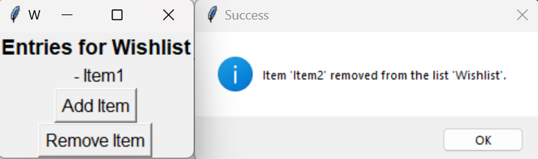

Test Case 2 – Store Actions
Initial state – List created by customer (Wishlist). No items in inventory. The expected outcome after the below tests is a store named Ivory with 1 item.

- Store can view customer list
- Store can add items to inventory (For store named “Ivory”)
- Store can view inventory
- Store can view the showcase

Results – The item was successfully added to the inventory of the test store “Ivory”.
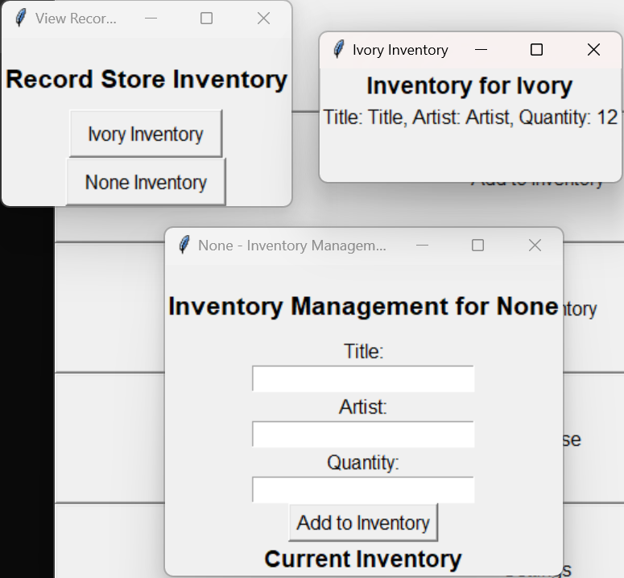

Test Case 3 – Settings
Initial state – No settings changes. The expected outcome after the below tests is a green background with a larger font.

- Change the background color to green
- Change the font to Arial 20
